**CHANDIGARH UNIVERSITY**

**UNIVERSITY INSTITUTE OF ENGINEERING**

**DEPARTMENT OF COMPUTER SCIENCE & ENGINEERING**



|  |  |
| --- | --- |
| **Submitted By: SANSKAR AGRAWAL Submitted To: Er. RAHUL BHANDARI** | |
| **Subject Name** | Competitive Coding |
| **Subject Code** | 20CSP-314 |
| **Branch** | CSE |
| **Semester** | 5th |
|  |  |

**LAB INDEX**

**NAME**: SANSKAR AGRAWAL **SUBJECT NAME:** Competitive Coding Lab

**UID:** 20BCS5914 **SUBJECT CODE:** 20CSP-314

**SECTION:**20BCS_MM_806_B

|  |  |  |  |  |  |  |  |
| --- | --- | --- | --- | --- | --- | --- | --- |
| **Sr.**  **No** | **Program** | **Date** | **Evaluation** | | | | **Sign** |
| **LW**  **(12)** | **VV**  **(8)** | **FW**  **(10)** | **Total**  **(30)** |
|  |  |  |  |  |  |  |  |
|  |  |  |  |  |  |  |  |
|  |  |  |  |  |  |  |  |
|  |  |  |  |  |  |  |  |
|  |  |  |  |  |  |  |  |
|  |  |  |  |  |  |  |  |

# Experiment – 2

## Problem Statement 2.1 Equal Stacks

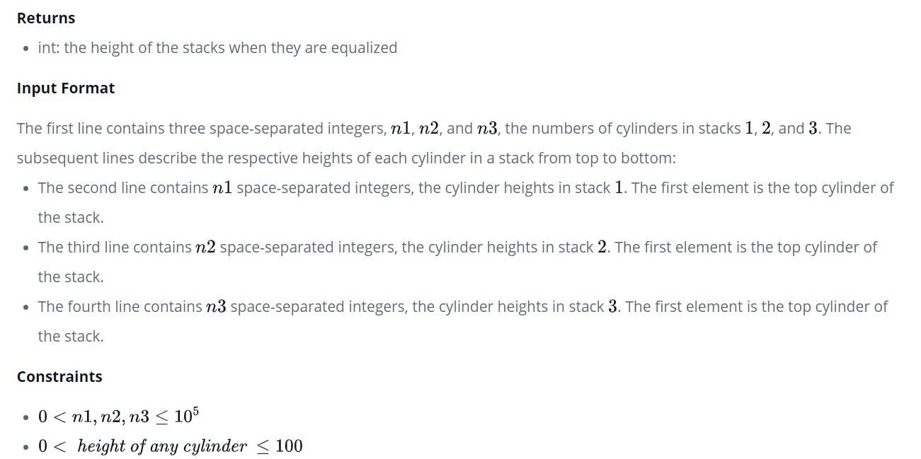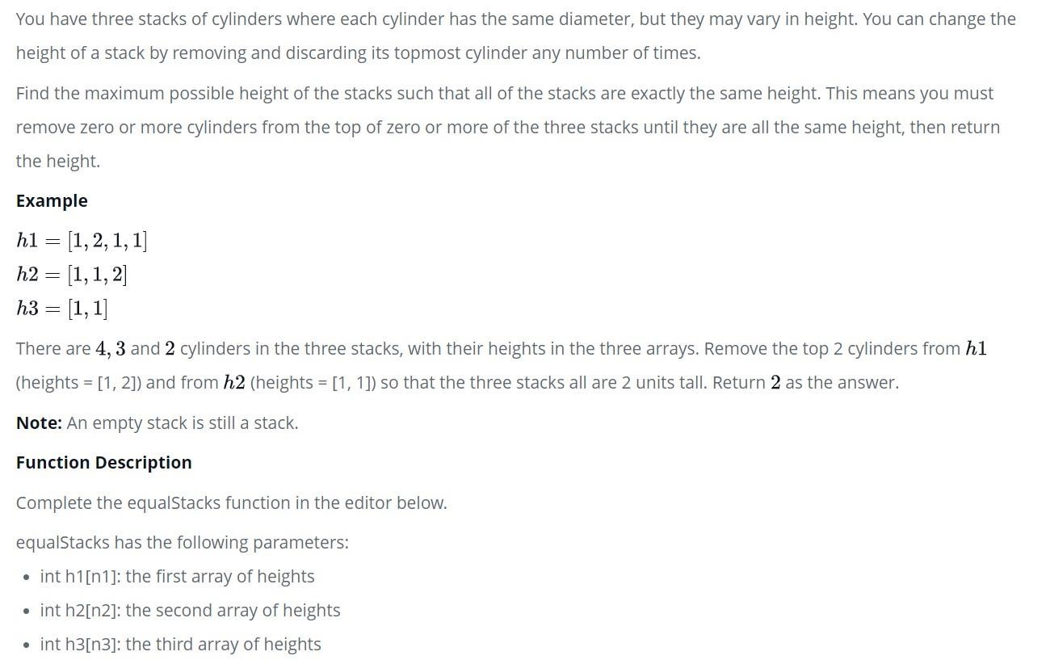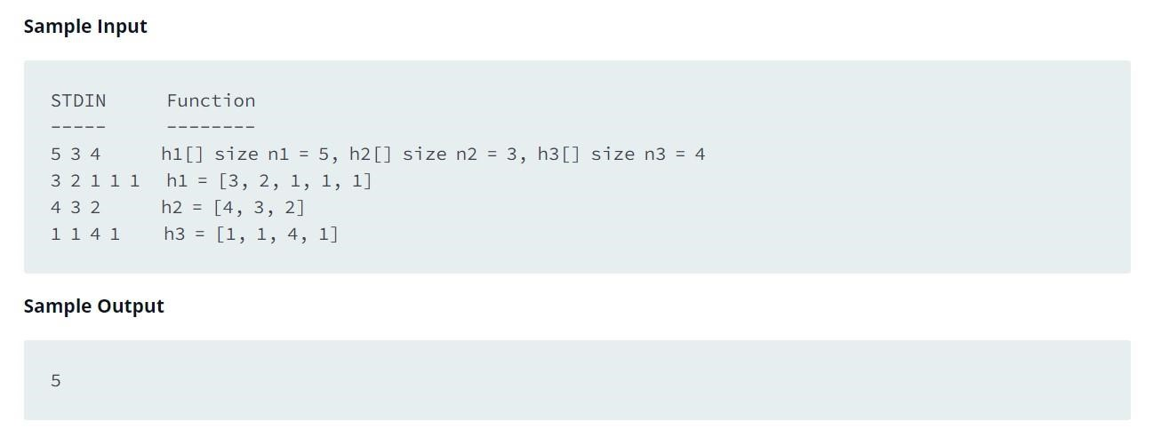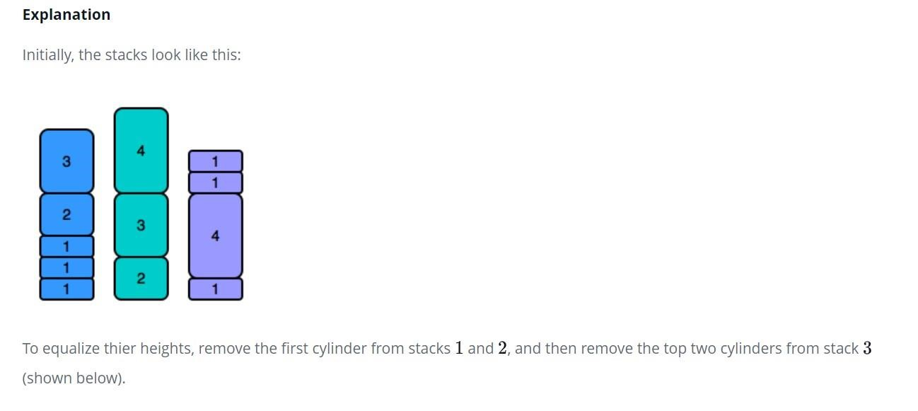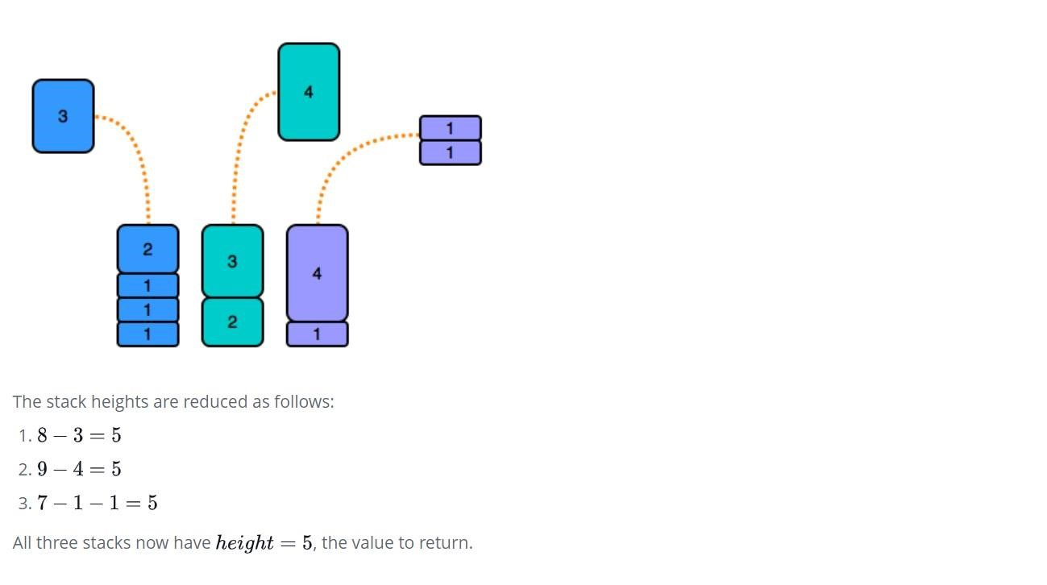

**Solution:**

/*

* Complete the 'equalStacks' function below.

*

* The function is expected to return an INTEGER.
* The function accepts following parameters:
* 1. INTEGER_ARRAY h1
* 2. INTEGER_ARRAY h2
* 3. INTEGER_ARRAY h3

*/

int equalStacks(vector<int> h1, vector<int> h2, vector<int> h3) { int n=h1.size(); int m=h2.size(); int p=h3.size(); stack<int>a,b,c; int sum1=0,sum2=0,sum3=0; for(int i=n-1;i>=0;i--){ sum1+=h1[i];

a.push(sum1); }

for(int i=m-1;i>=0;i--){ sum2+=h2[i];

b.push(sum2); }

for(int i=p-1;i>=0;i--){ sum3+=h3[i];

c.push(sum3); } while(1){ if(a.empty()||b.empty()||c.empty()){ return 0;

}

if(a.top()==b.top() && a.top()==c.top()){ return a.top();

}

else if(a.top()>=b.top()&&a.top()>=c.top()){

a.pop(); }

else if(b.top()>=a.top()&&b.top()>=c.top()){

b.pop();

}

else {

c.pop(); }

}

}

**Output:**

